February Newsletter
First Chance for Children
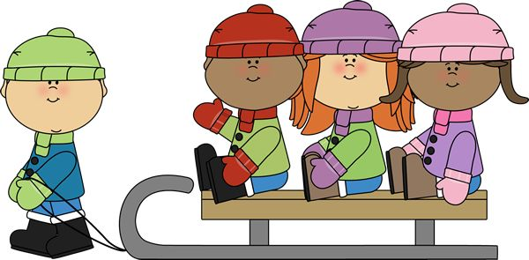

Upcoming Events

March
During the Month of the Young Child we will be having a HUGE event! Stay tuned for all the exciting details!

Lend and Learn Library
Lend and Learn Library is open from 9-12:30 every Monday-Thursday. It is closed any day Columbia Public schools are closed.
At the L&L you can bring any child under 3, and their siblings up to age 5!
We always have a child care specialist on staff to answer any questions you might have about your growing child.
Don’t have time to stay and play? That’s okay! We provide toys and games for check out.

1010 Fay St. Columbia, MO 65201
http://www.firstchanceforchildren.org/ T: (573) 777-1815
Follow us on Facebook & Twitter
First Chance for Children | @FC4children
Dear reader,
We are so sorry we missed you in January! It is hard to believe the first month of the year is already over! This February we are looking forward to the exciting events ahead! Read below for more information!
Warm regards,
First Chance for Children

In the News
Car Seat Safety
Did you know your child shouldn’t wear their coat in their car seat?

Bulky winter coats can be a serious threat to your child’s safety. While the straps may feel snug, they are actually dangerously loose! They feel tight against the coat, however they are not tight against your child, and in an accident, your child could slip right out of their seat. A video here shows how serious the consequences can be: http://on.today.com/1TL1F6w

What are some alternatives in this cold weather? Place a blanket or their coat over the seat belt straps, so that you know your child is warm and secure. You could also have a smaller, less bulky coat for them to wear in the car, and place the heavier one on once they get out.

Spotlight on: Our Community
First Chance for Children would like to extend a HUGE thank you for all the donations and gifts we received in December during COMOGives! Without our supportive community we would be unable to serve our families in the way we do! Looking for more ways to help now that December is over? You can make a donation on our webpage, or donate a variety of items that we constantly need. To find out what our current needs are give us a call, or send us an email!

More Important News
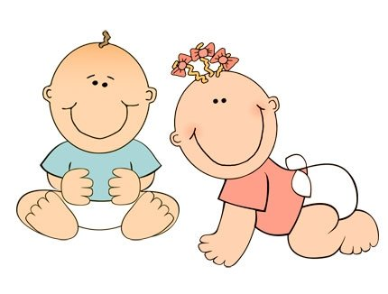

In the Community

Clifford the Big Red Dog Live!
See Clifford live at Jesse Hall on February 10Th! Check concertseries.org for tickets and details!

Library Programs
Did you know your public library offers free programs for you and your child? Check out your library’s webpage for more details.

Looking for more?
Check out comokidsfun.com for tons of great activities right here in Columbia

Safety tip: What kind of car seat should I be using?
It can be hard to know when your child is ready to change car seats. This handy chart from the American Academy of Pediatrics makes the decision easy.
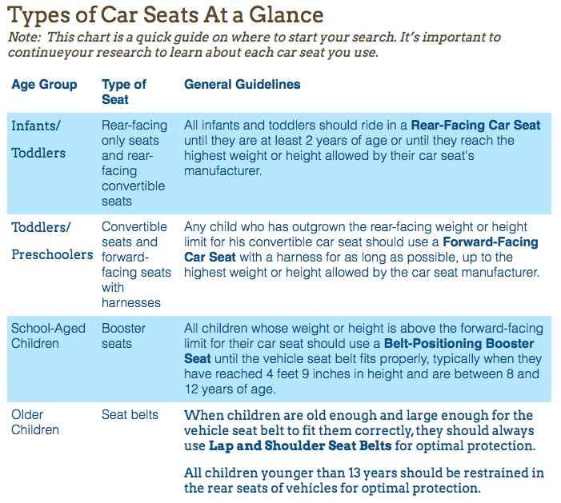
Activity: Valentine’s Day prints
Grab a doily, some red paint, and a foam brush. Paint your baby’s hand and press it on the doily. Let dry and you’ve got a beautiful keepsake! If you have some older ones, use a cookie cutter and let them make pretty prints!
